**SEMESTER TWO 2017**

**YEAR 12, Units 3 & 4**

**MATHEMATICS METHODS**

**Section Two – Booklet 3**

**(Calculator–assumed)**

**Name: _________________________________**

|  |  |  |  |
| --- | --- | --- | --- |
| **MAW** | **VMU** | **MPC** | **AGC** |

**Teacher:**

**TIME ALLOWED FOR THIS SECTION**

Reading time before commencing work: ten minutes

Working time for section: one hundred minutes

**This page has intentionally been left blank.**

**Question 15 (3+1+2+2 = 8 marks)**

The velocity. *v* m/s, of an object moving in a straight line is given by , where *t* is measured in seconds. The object is initially at the origin, O.

Determine:

a) the displacement, *x*, at any time *t*.

b) the acceleration, *a*, at any time *t*.

c) the first-time the object returns to the origin. Give your answer as an exact value.

d) the distance travelled in the first 5 seconds.

**Question 16 (3+4 = 7 marks)**

A new badge for Prefects is to be fabricated. The shape of the badge is shown below.

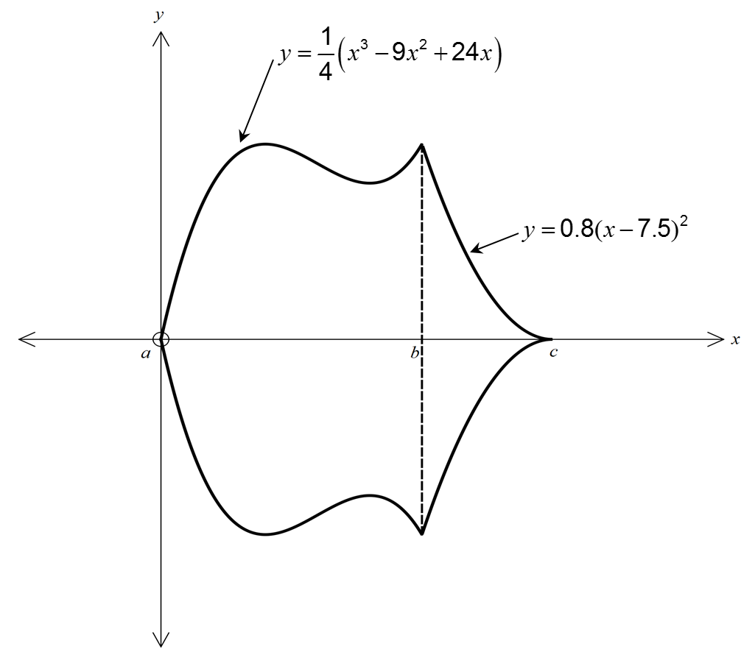

The badge is symmetrical about the *x*-axis and 1cm is represented by 2 grid units on each axis.

a) determine the values of *a*, *b* and *c*

b) Calculate the area of the badge in cm².

**Question 17 (2+2+2 = 6 marks)**

From reliable census data, it has been established that 30% of Australian families watch the News on free to air television each night. If five randomly selected families are surveyed one evening and the number of families who watch the News on free to air television each night, *X*, is recorded:

a) State the distribution and its parameters.

b) Determine the mean and variance of this distribution.

c) Calculate the probability that at least two families watched the News on free to air television.

**Question 18 (3+3+3 = 9 marks)**

Mark has a pop-up shop that sells “Fidget Spinners”. After a while he realises 8% of the Fidget Spinners he sells are returned, as they are defective. Mark is prepared to replace a spinner if the customer returns with the defective toy. Assume that all customers with a problem return for a replacement Fidget Spinners and that *F*, represents the number of Fidget Spinners returned per day, is a binomial random variable.

a) Determine the probability that if on a day where 55 Fidget Spinners are sold:

i) none will be returned,

ii) exactly 10 will be returned,

iii) at most five are returned.

**Question 18 continued**

b) What is the maximum number of Fidget Spinners that can be sold on one day so the probability that at most 6 defective spinners are returned is greater than 0.99?

c) Vaughan opens a rival pop-up shop selling Fidget Spinners. He chats with Mark and finds he has had similar experiences with defective toys being returned. For Vaughan, the expected number of spinners he replaces per day is 8.432 and this can be modelled by a binomial random variable with a variance of 7.386432. Calculate how many Fidget Spinners are sold by Vaughan per day and the proportion that are defective.

**Question 19 (3 marks)**

One hundred and ninety out of a sample of two hundred and fifty Doubleview ratepayers do not want the International School relocated from City Beach to the Doubleview Primary School site.

Within what range of percentages of ratepayers can we be 95% confident that the ratepayers of Doubleview do not want the International School relocated from City Beach to the Doubleview Primary School site?

**Question 20 (3+3 = 6 marks)**

a) In WA the probability of those in favour of lowering the voting age to 16 is unknown.

What sample size should be used to estimate the probability of those in favour of lowering the voting age to 16 with an error margin of 10% and confidence level of at least 95%.

(Hint: Use *p* = 0.5 to ensure valid confidence limits.)

b) If the confidence level in (a) is 90% instead of 95%, would the sample size be larger or smaller? Provide evidence to support your answer.

**Question 21 (3+4 = 7 marks)**

Given ,

a) graph the function for  on the axes below. Clearly indicating key features.

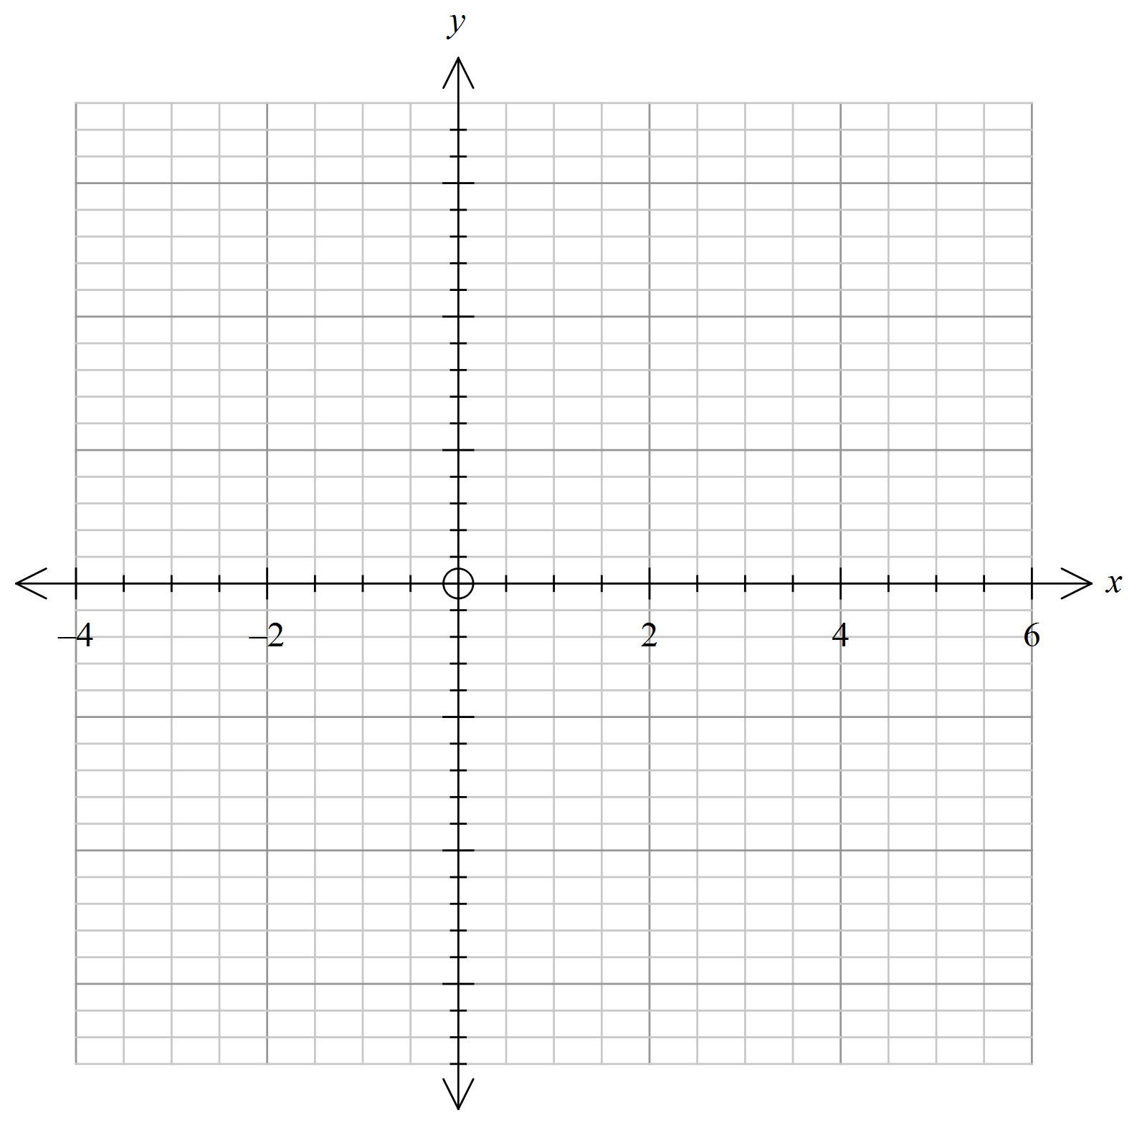

End of Questions for Section 2

b) On the same set axes graph the accumulation function, , where

 for 

Clearly indicate key features.

**End of Questions for Booklet 3**

Spare Working Page

Spare Working Page

Spare Working Page